Setup Instructions

  - Install Xcode (latest stable recommended).
  - Open one project at a time
  - Select the app target and a simulator or device.
  - Build and run.
  - Allow notifications if prompted (used for reminders in ToDoList and optional features in PersonalityQuiz)-
  - When navigating/ using Figma please look to the left, you’ll find both prototypes, click whichever you’d like to run!

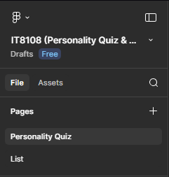
Figma Link: https://www.figma.com/design/GrIVMIoybtc2eLQuoYMc1K/IT8108--Personality-Quiz---Project-List-?node-id=0-1&t=nddkQHVoVrY2vZxc-1

Student: Diana Khalid Flaifel
Student ID: 202203875

